Game Project Progress:

26/06/2019

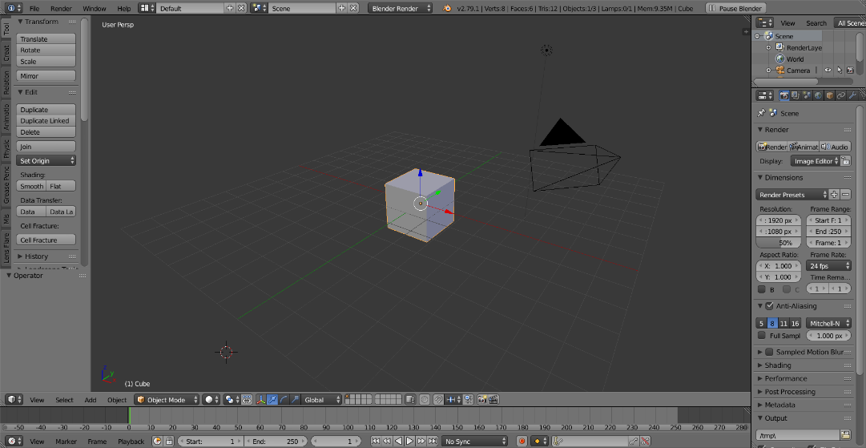

Started Modelling the Player Head from scratch

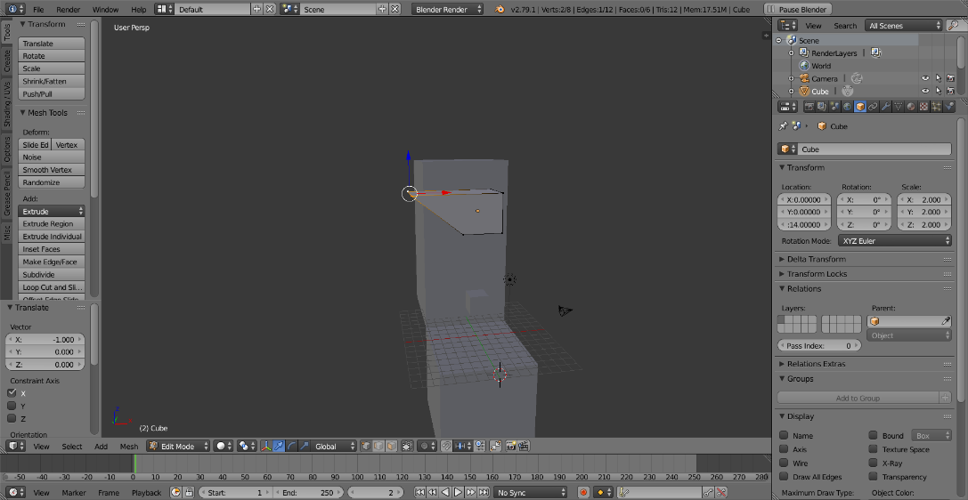

Created the basic shape by moving the vertices at fixed intervals for consistency.

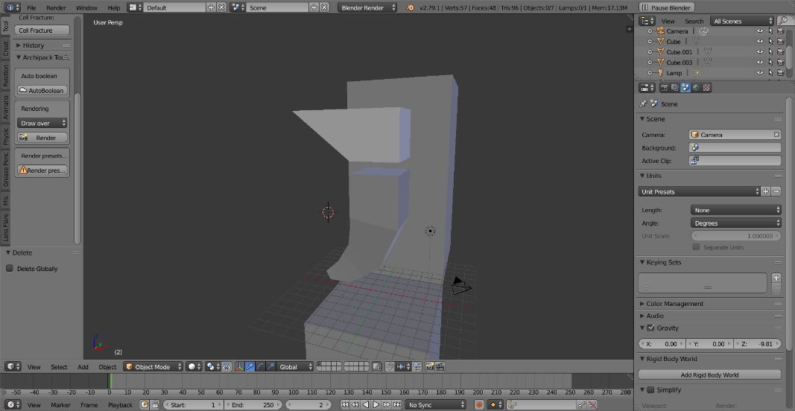

Generated a string of vertices and implemented a skin modifier for the body’s shape.

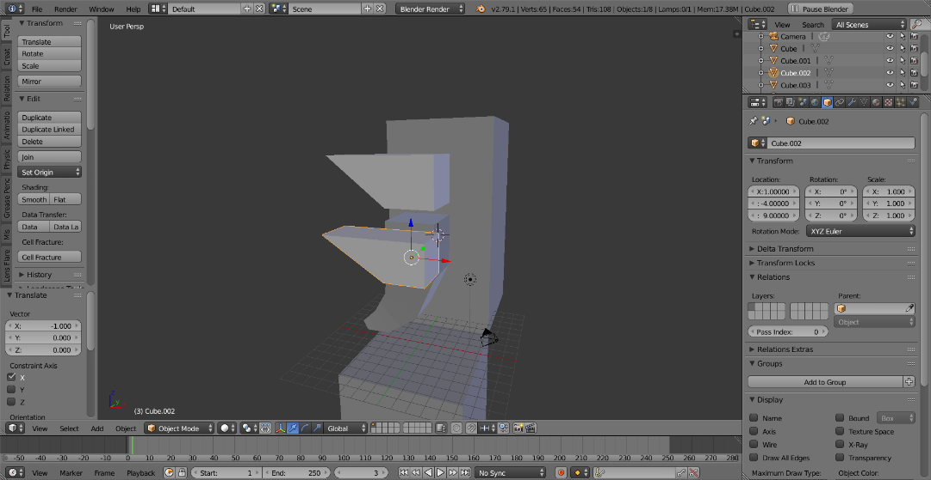

Replicated the head’s basic shape with minor adjustments in shape to tell them apart.

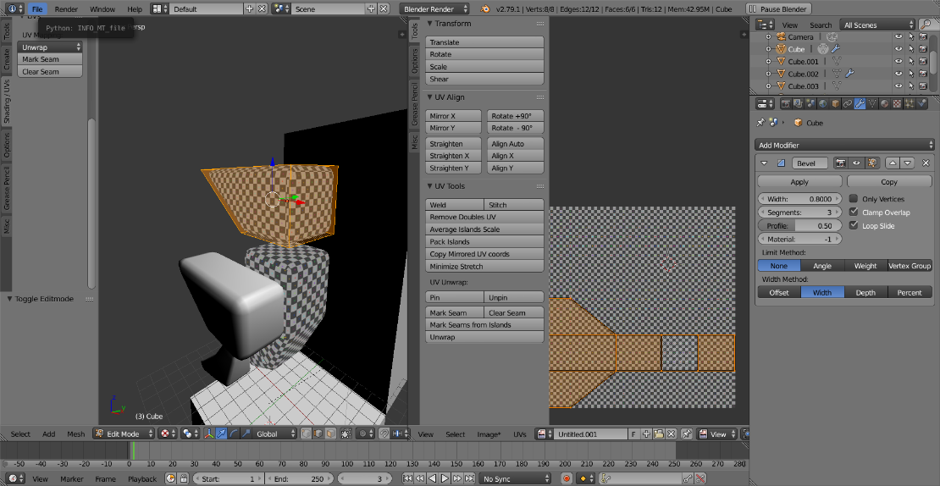

Created the leg meshes using the same Skin modifier method, began implementing bevel modifiers for a smooth look.

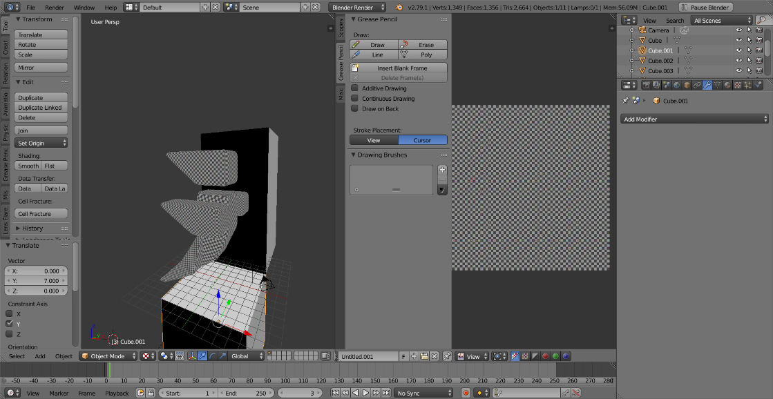

Duplicated and mirrored the arms and legs, and unwrapped all the body parts.

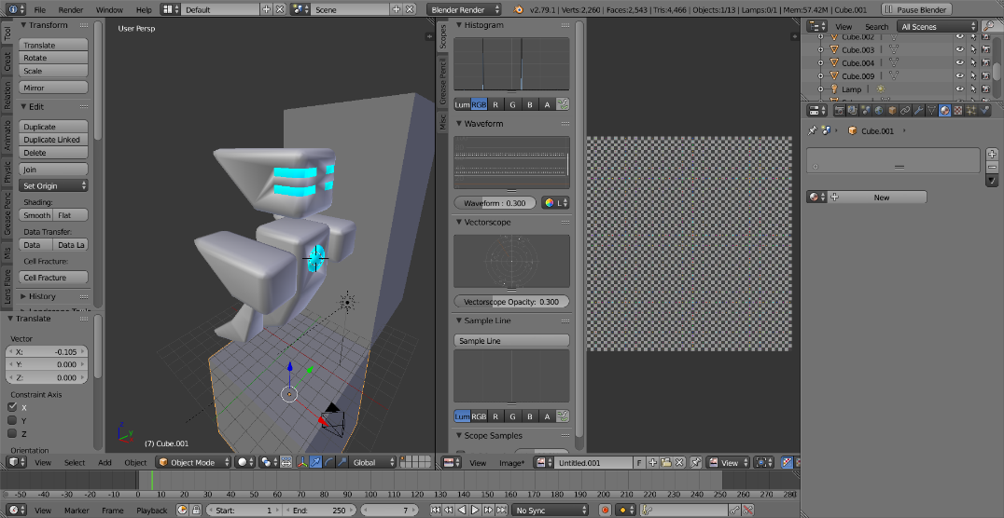

Implemented a Boolean operation on the head mesh for the eyes, and rewrapped mesh.

27/06/2019

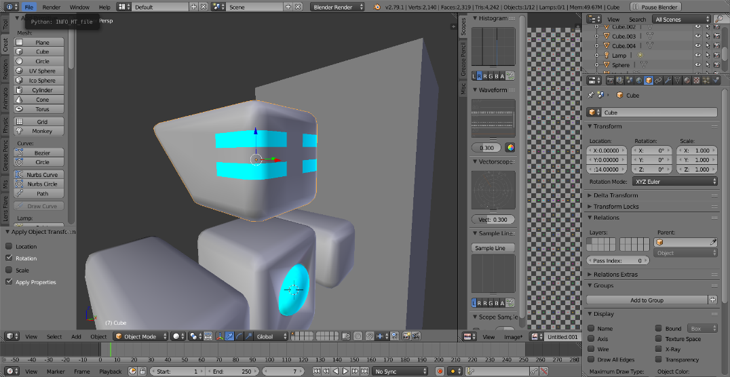

Removed the eye mesh, filled the holes in the mesh and rewrapped the head mesh to make it look smoother.

1/07/2019

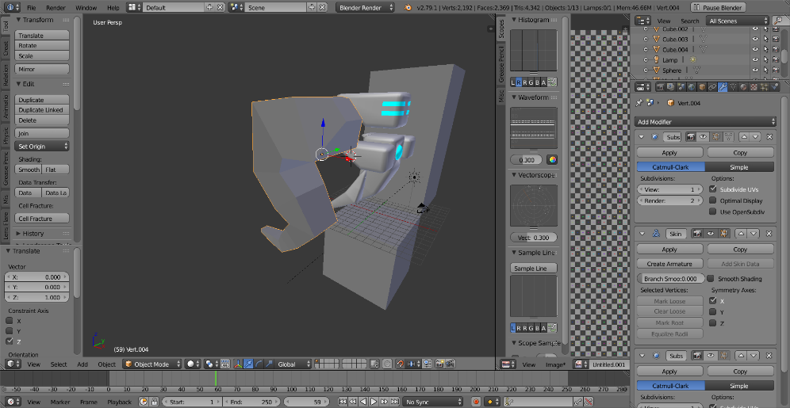

Began building Sergent123’s body mesh using the skin modifier on a string of vertices for the basic shape.

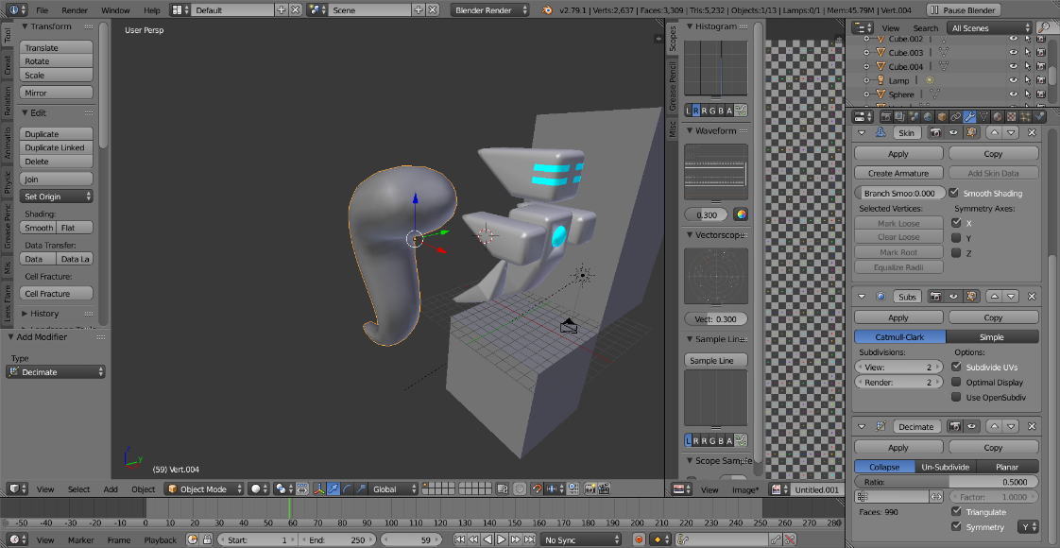

Applied the subdivide modifier on the body followed by the decimate modifier for a smooth round shape that doesn’t use too many triangles to prevent any unnecessary lag.

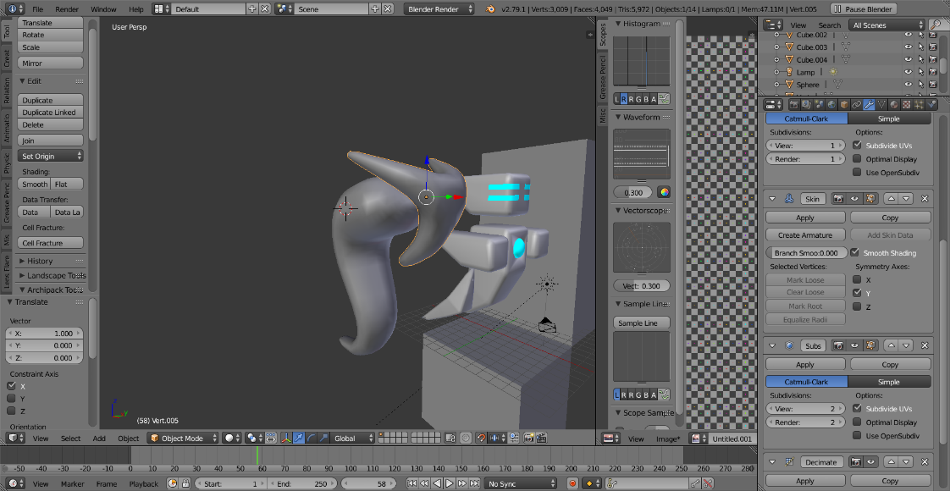

Created the head mesh using the skin modifier, followed by subdivide and decimate.

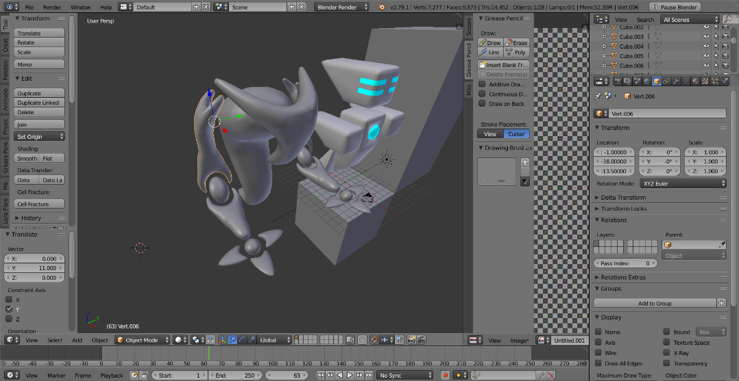

Created the arm meshes using the modifiers skin, mirror, subdivide and decimate on each arm piece, then duplicated and mirrored the arm to create the other arm.

2/07/2019

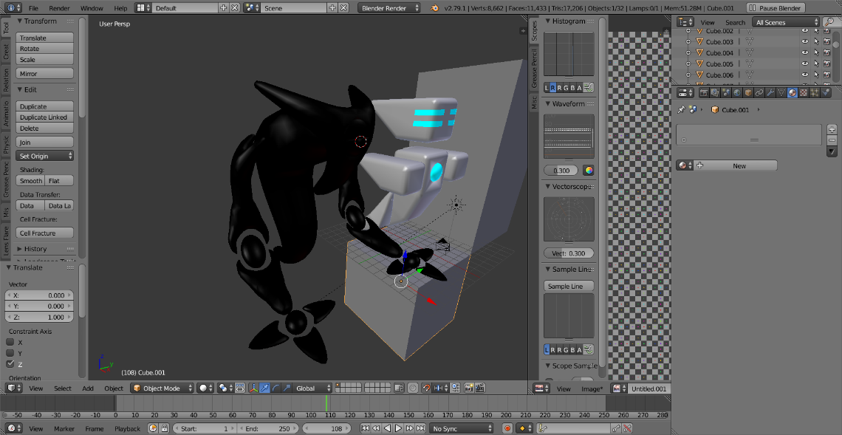

Added a Boolean operation for the head to create the eye as well as the eye lids.

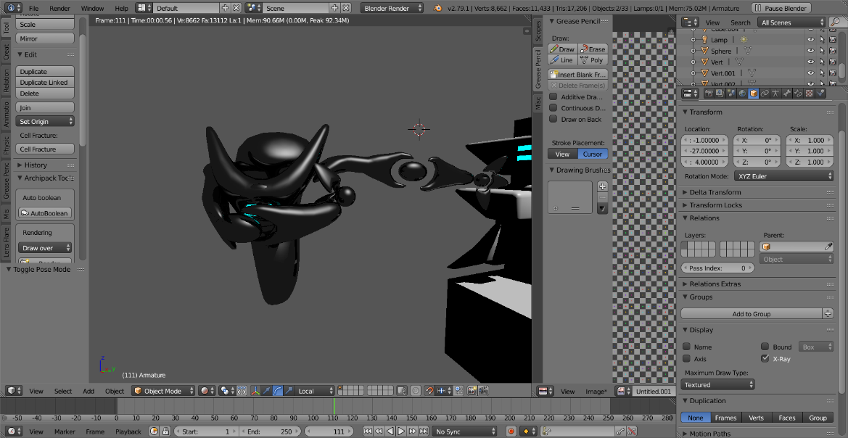

Successfully created an armature rig for Sergent123 to easily animate him.

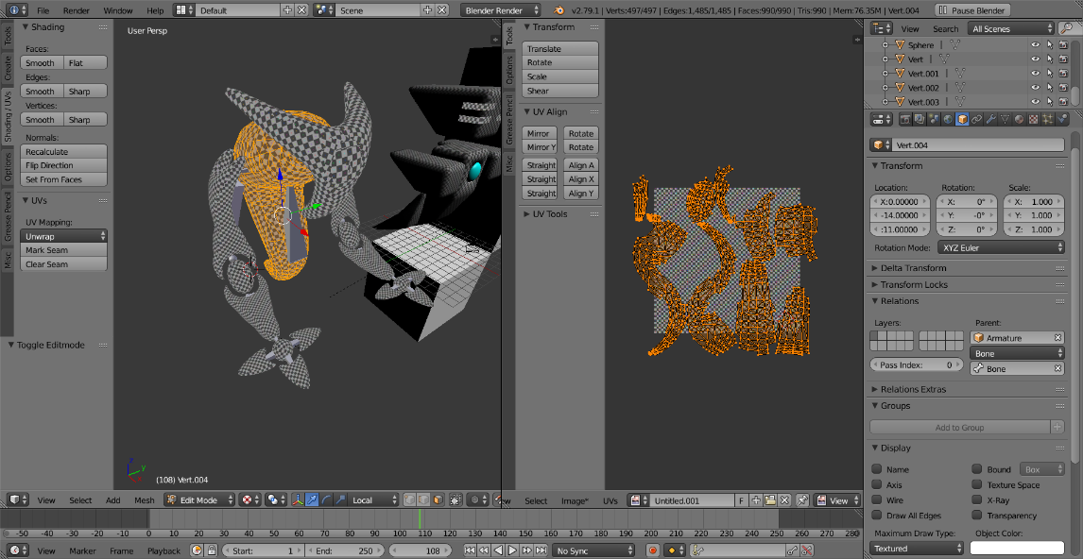

Unwrapped all of the meshes while maintaining a consistent texel density.

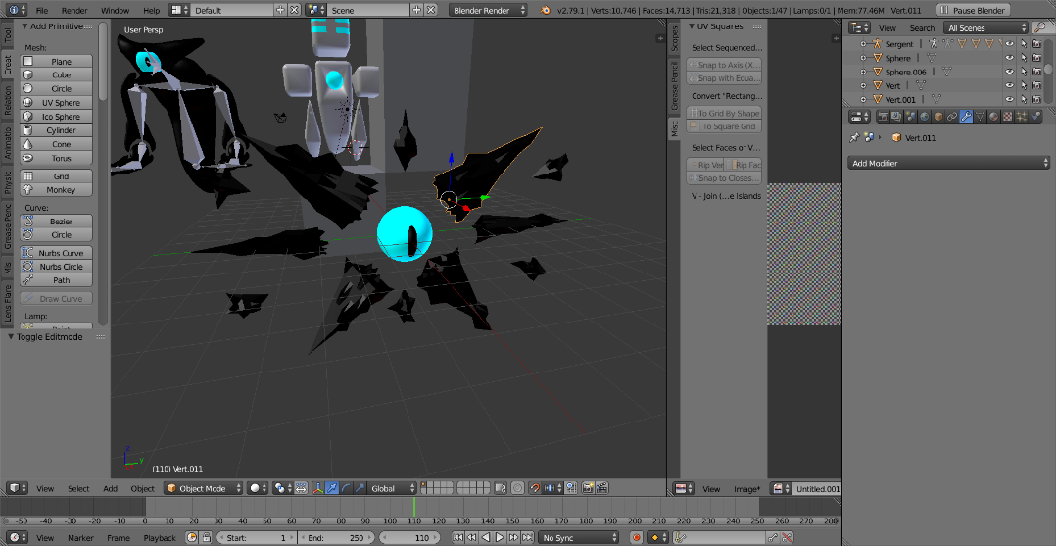

Created the meshes for the fragments by subdividing them and then adding a displacement modifier with a specific generated texture that determines the jagged shape of the meshes.

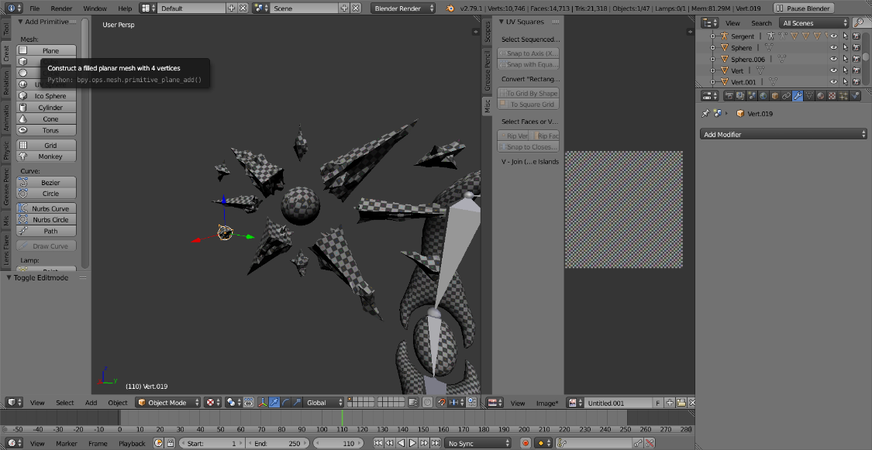

Unwrapped all of the meshes while maintaining texel density.

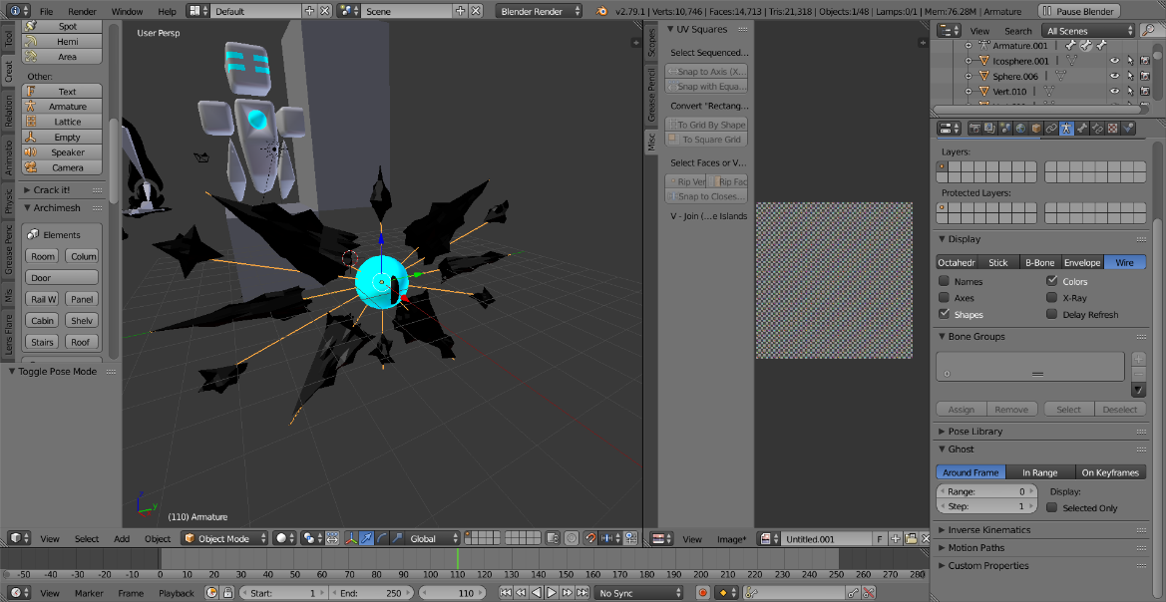

Created an armature rig to easily animate the character.

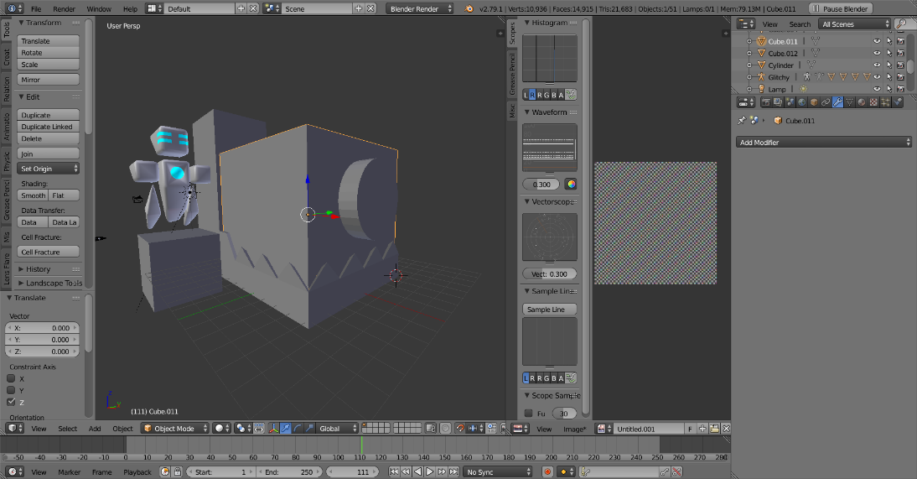

Generated the meshes by manipulating vertices and subdividing to create the head and jaw, followed by a Boolean to separate the head from the jaw.

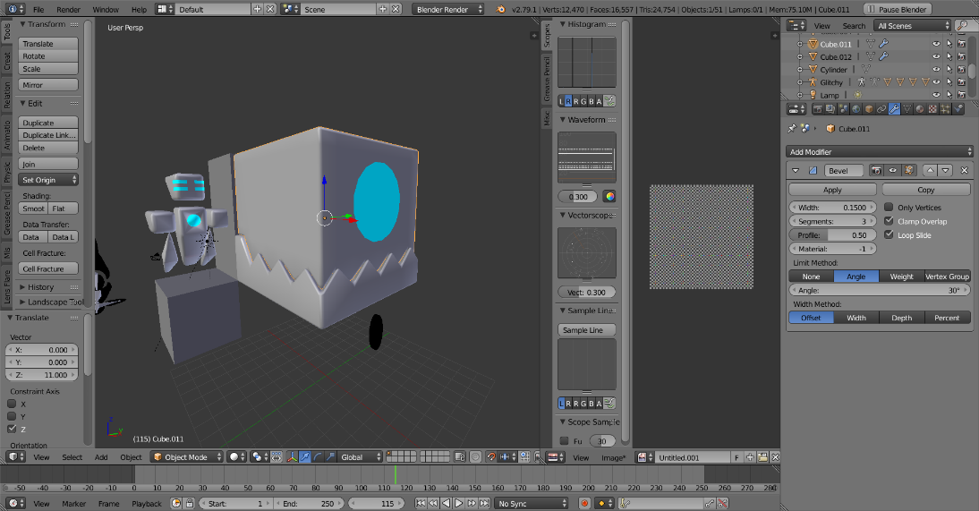

Implemented a bevel modifier for a smooth look, and used another Boolean for the eye and manually fixed and smoothed out the mesh.

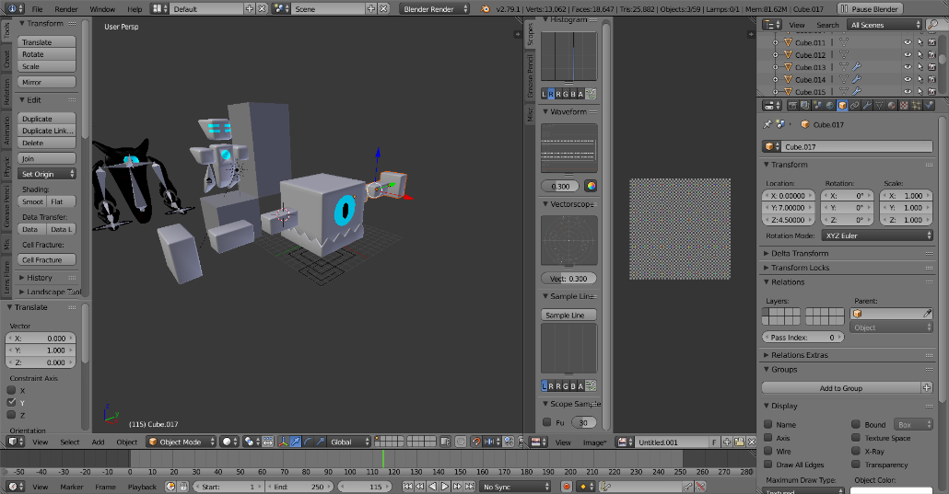

Generated some quick limbs by generating some cubes, setting their scale to 1 and then applying a bevel modifier for the consistently smooth design.

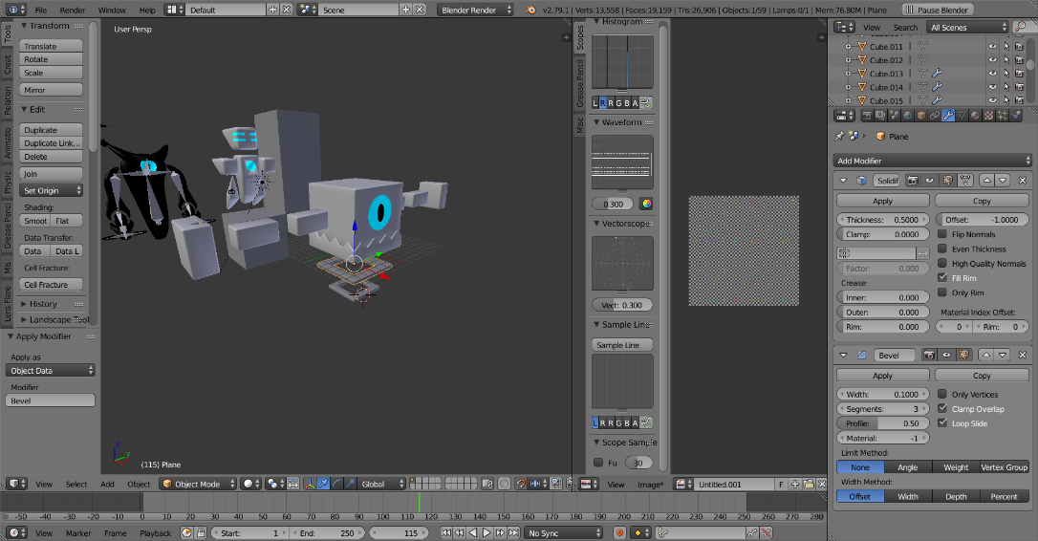

Created the square rings by generating a square made of edges and then applying the solidify modifier twice, followed by the bevel modifier.

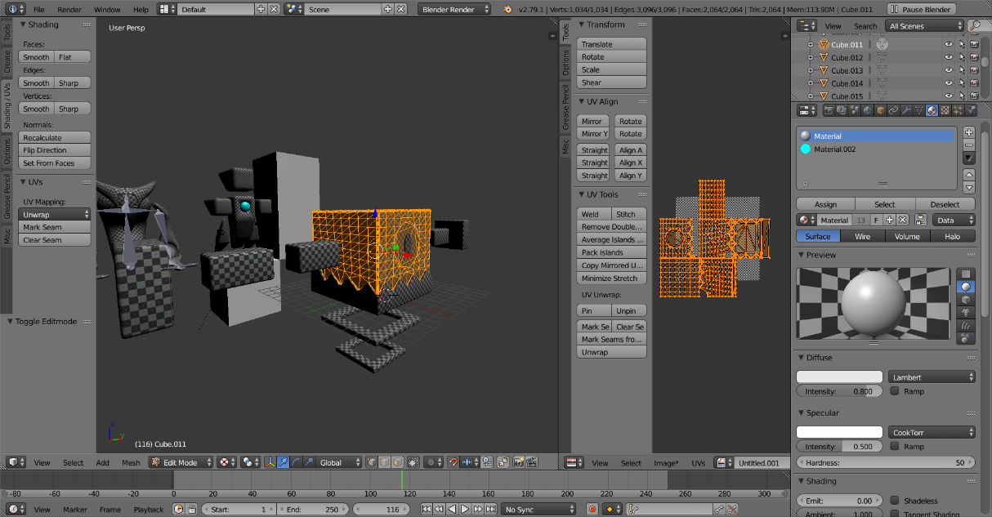

Unwrapped all of the meshes with consistent Texel density.

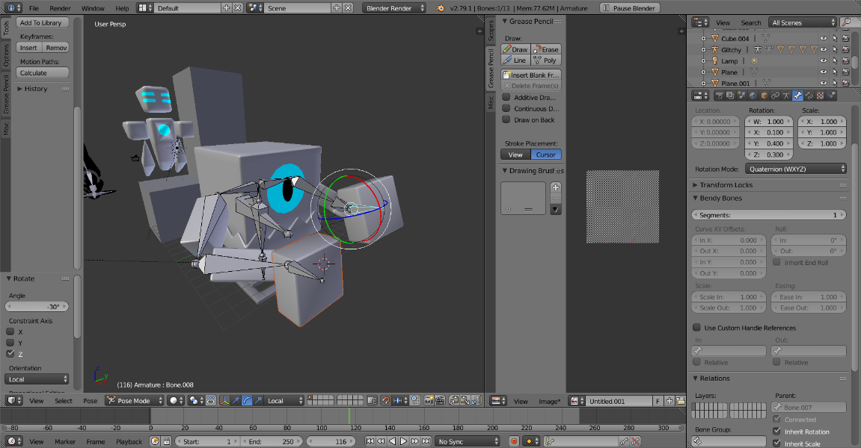

Created the armature rig for the Trainer Bot.

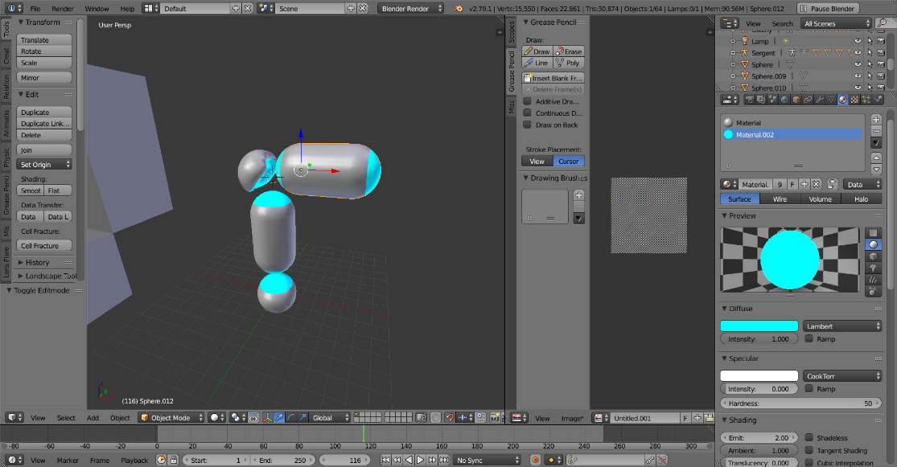

Created the meshes by manually modifying sphere meshes as well as using the sculpt tool for the ‘Knee cap’ mesh, followed by a lengthy manual fix to smooth out the mesh.

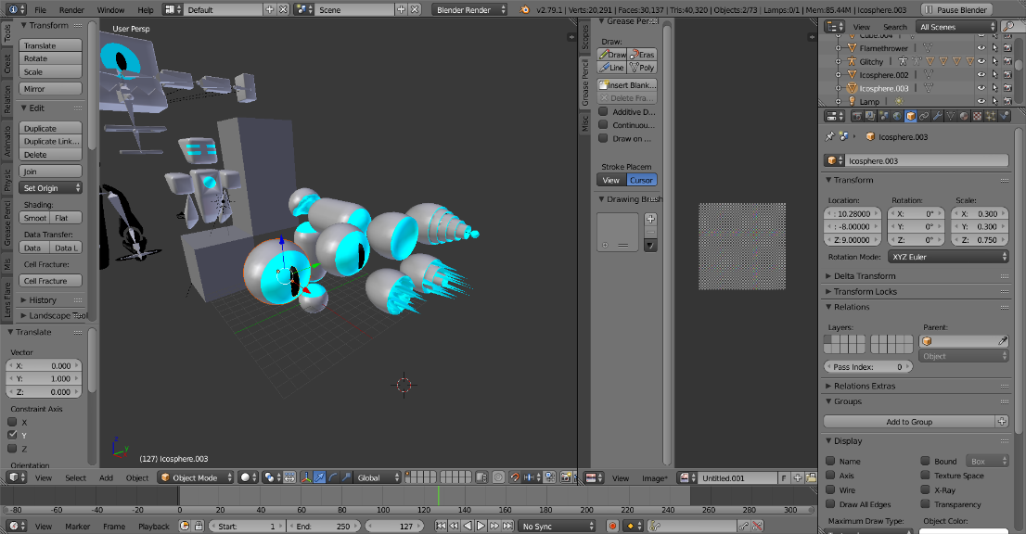

Created a series of different turret head meshes using Booleans as well as modifying vertices in each sphere mesh.

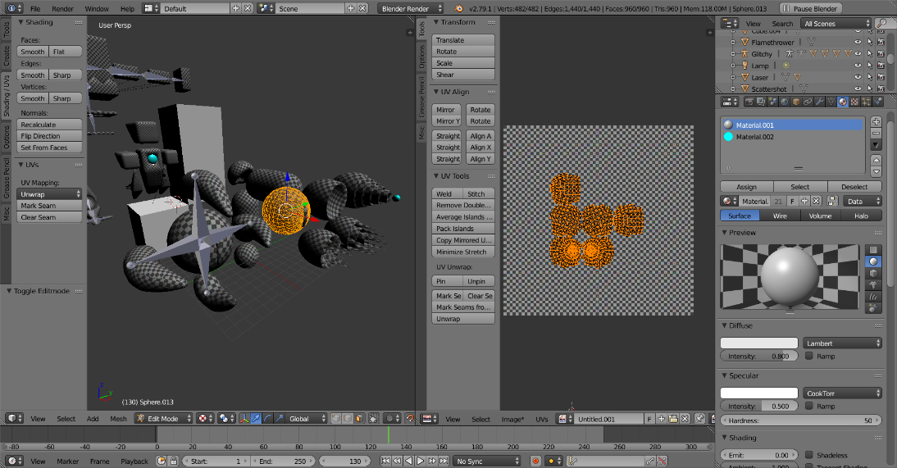

Used the skin modifier followed by subdivide and decimate modifier to generate the claw head, followed by a separate armature rig for the claw head, and then unwrapped all of the meshes.

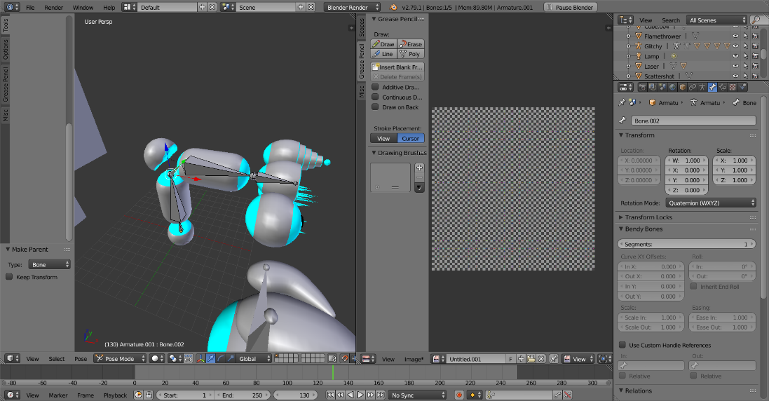

Created an armature rig for the turret body.

3/07/2019

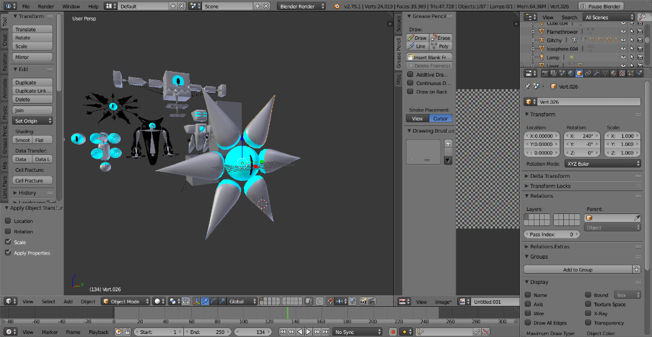

Generated the meshes for the ravager head using the skin modifier followed by subdivide and decimate multipliers.

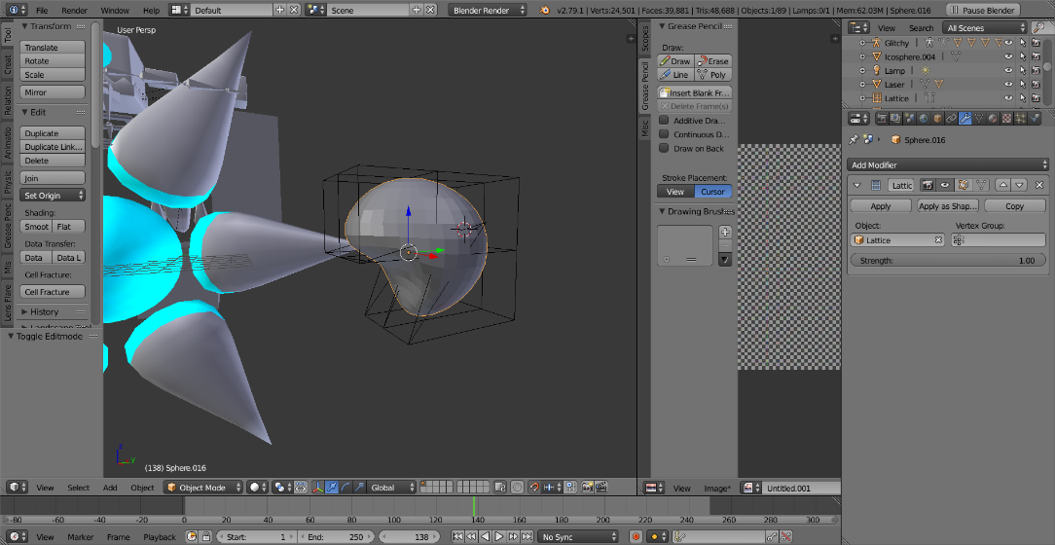

Created the ravager’s palm meshes by applying a lattice modifier to a sphere mesh.

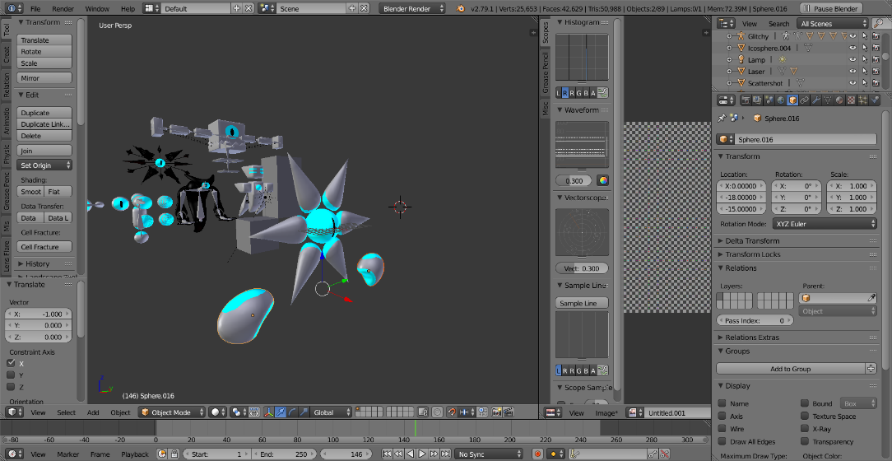

4/07/2019

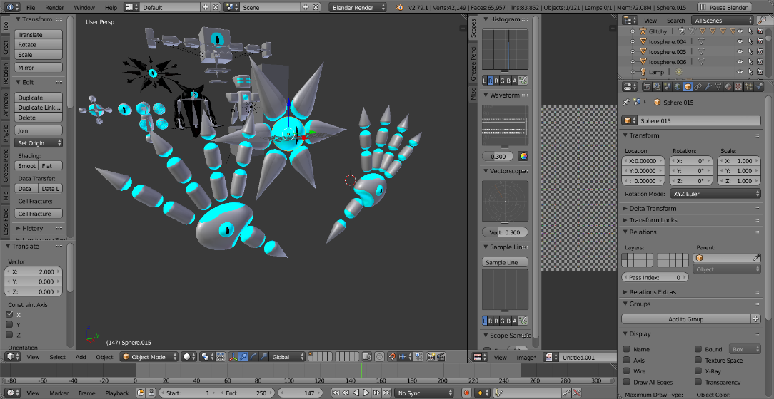

Created each finger piece by modifying a sphere mesh as well as merging vertices and applying subdivide/decimate modifiers.

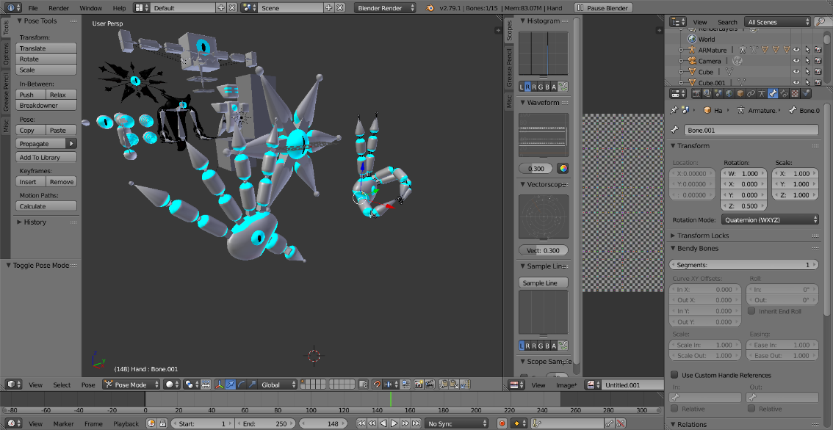

Created the armature rig for the head and hands.

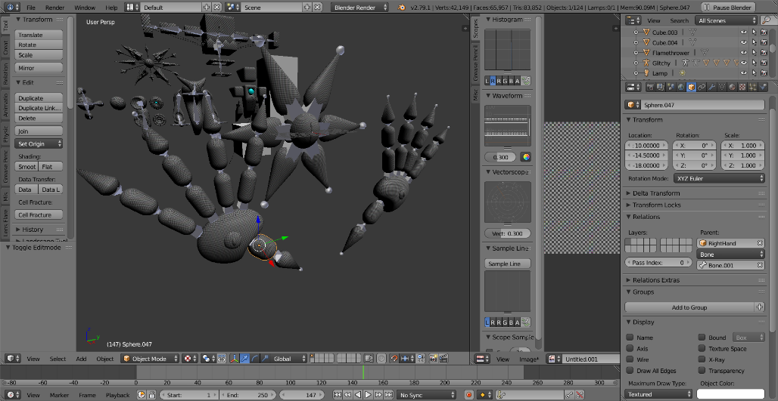

Unwrapped all of the meshes while maintaining a consistent Texel density.

5/07/2019

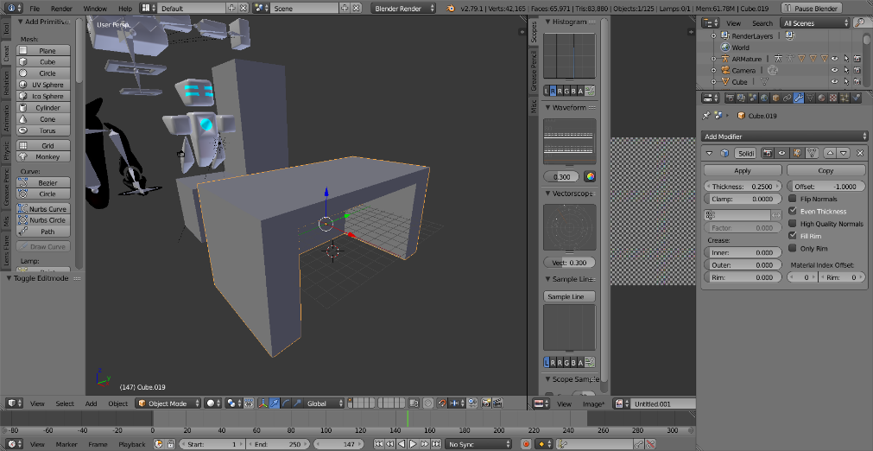

Created the table mesh by resizing a cube and deleting faces, followed by applying the solidify modifier.

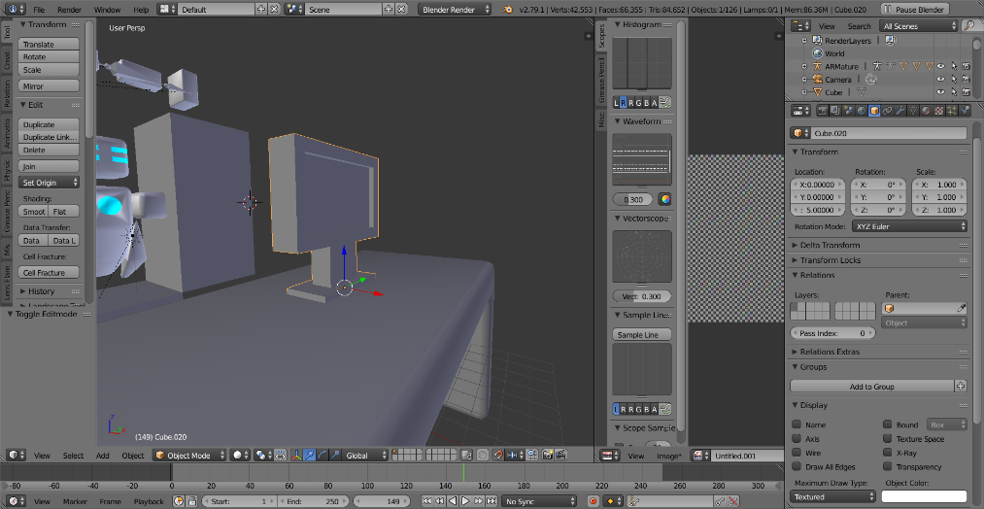

Generated the PC Monitor using extrude, and applied a bevel modifier to both meshes.

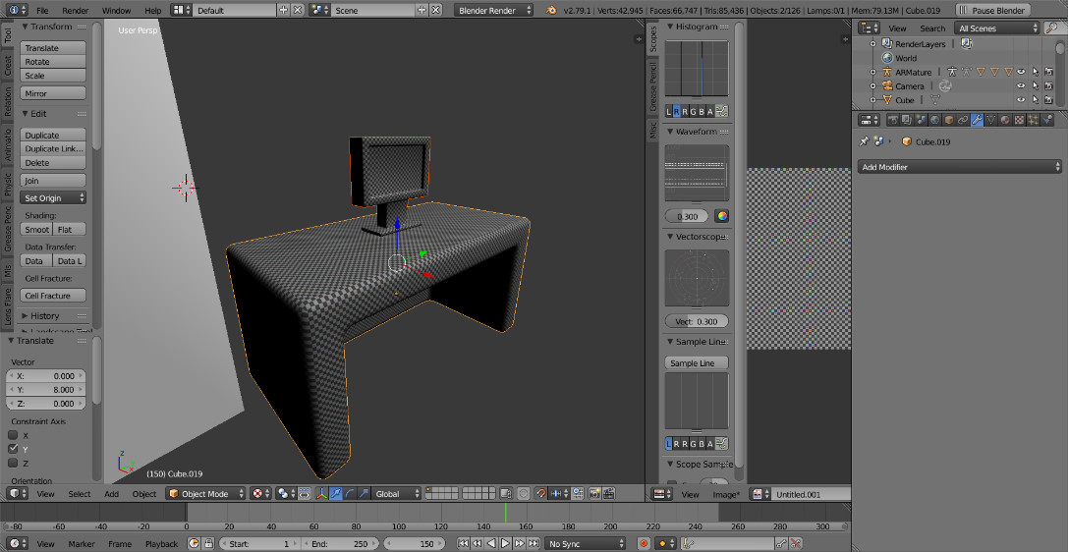

Unwrapped both meshes while maintaining a consistent Texel density.

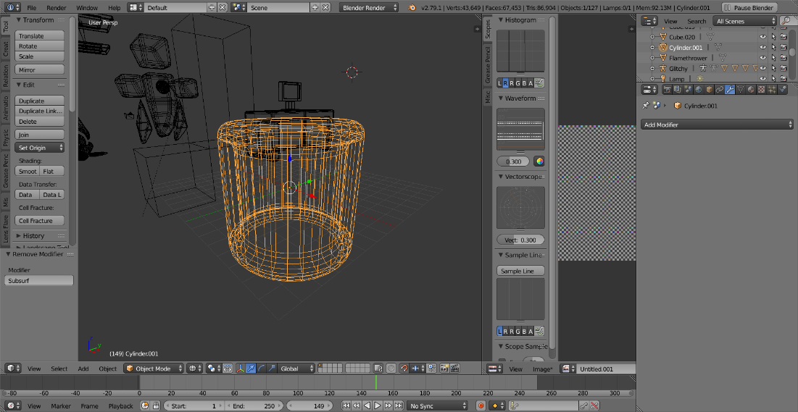

Generated the canister mesh using a cylinder and subdividing and extruding edges/faces, followed by bevel modifiers and unwrapping the canister mesh.

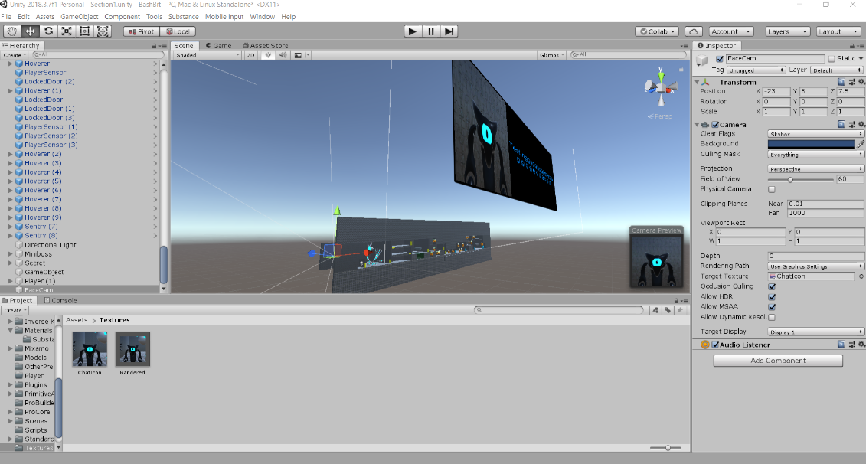

Exported and imported refined character rigs and implemented a render texture function.

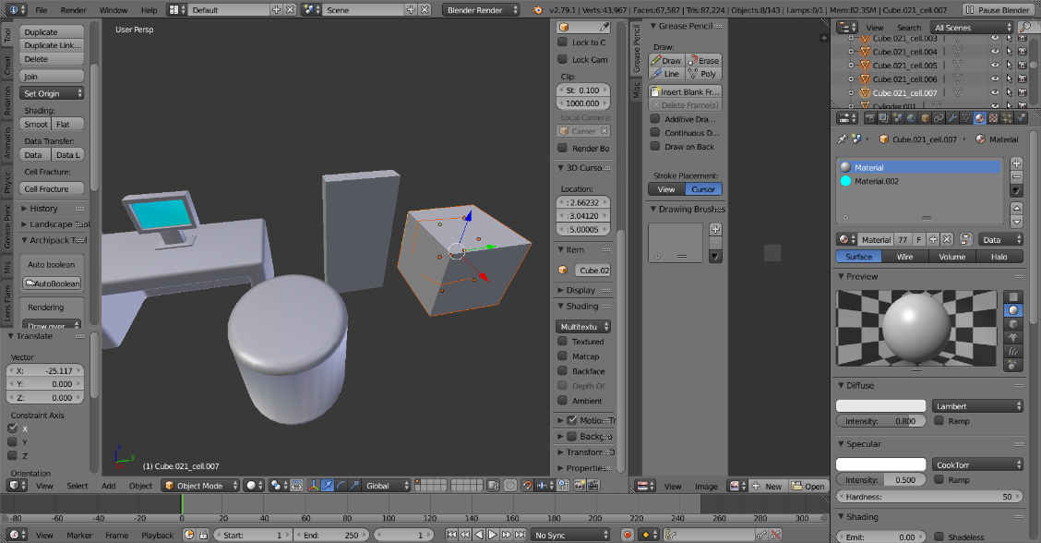

Created the meshes for the shattering door and blocks by unwrapping the meshes first and then applying the cell fracture add-on available on blender.

6/07/2019

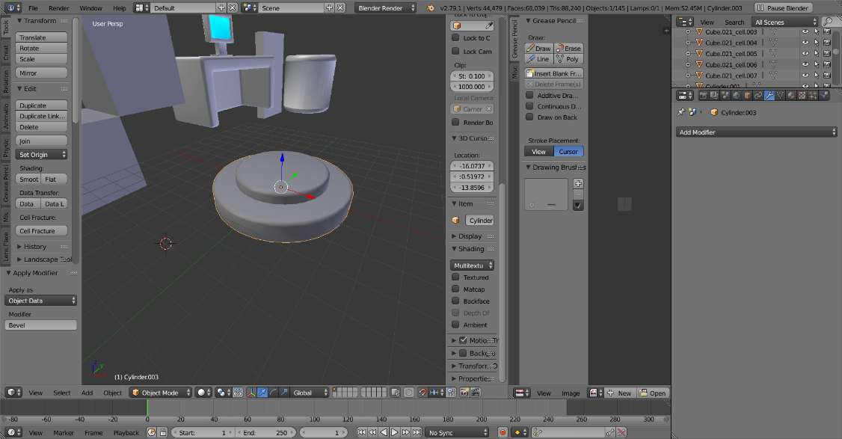

Generated the button mesh using cylinders with bevel modifiers applied.

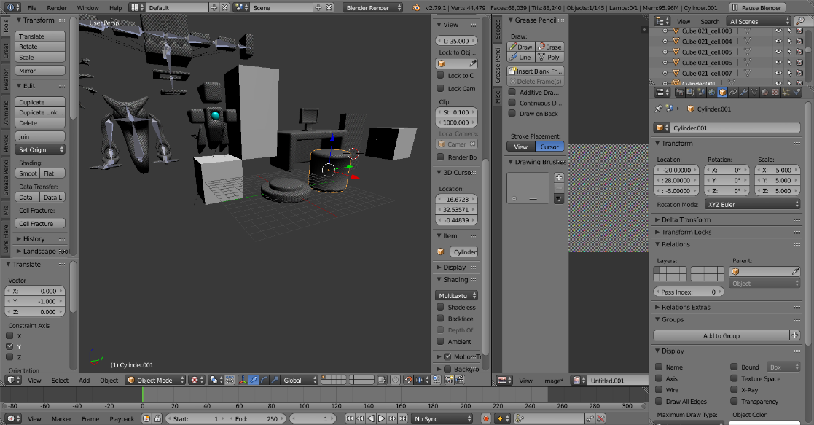

Unwrapped the button meshes.

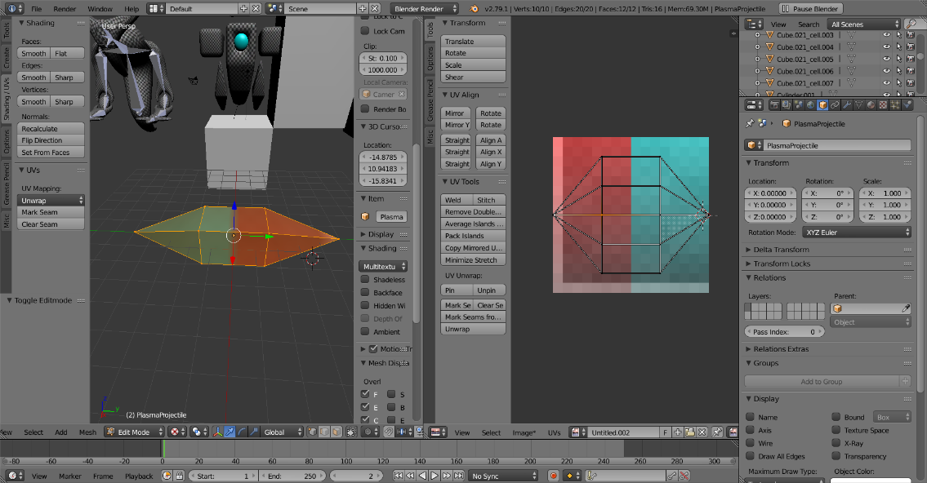

Generated and unwrapped the projectile mesh, exporting the UV texture to import on photoshop.

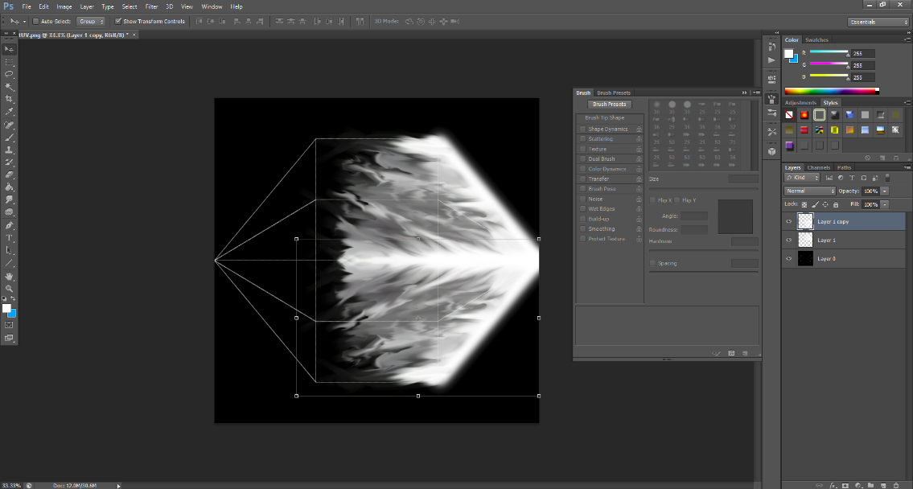

Created a projectile texture using the brush tool and the smudge tool, followed by mirroring.

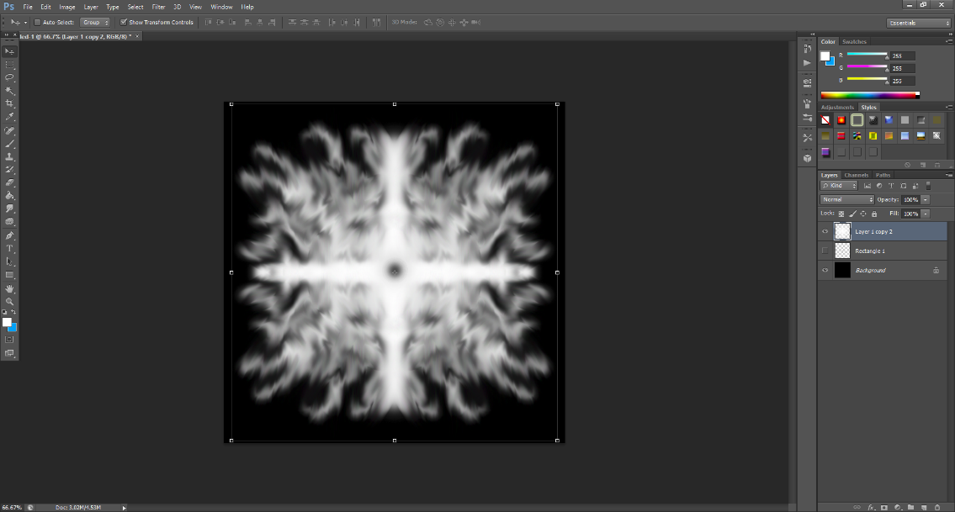

Created the explosion texture with the brush and smudge tool, as well as mirroring.

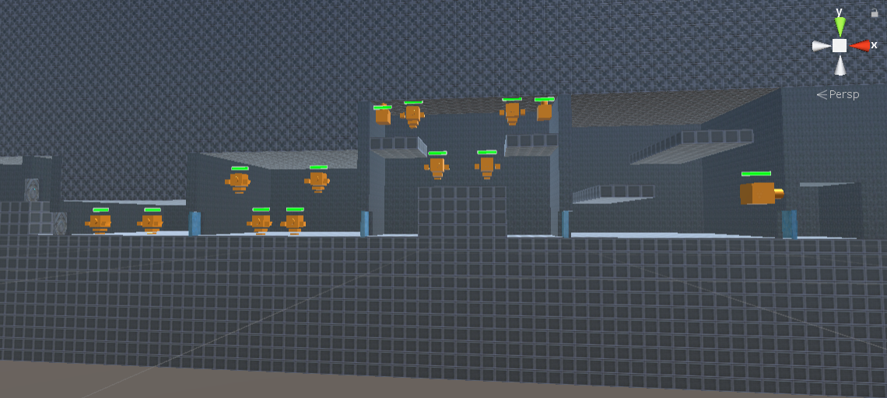

Implemented Substance materials on the walls in the level as suggested.

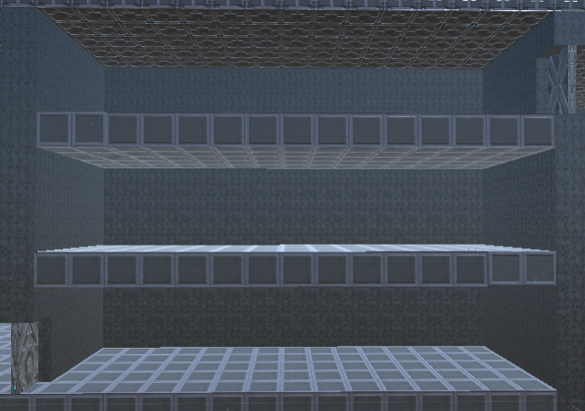

Successfully implemented destructible doors and fake floors.

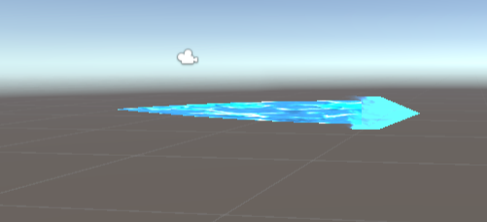

Generated the projectile particle.

7/07/2019

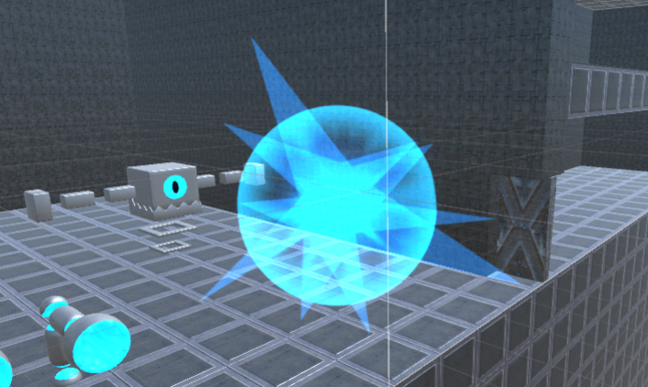

Created the hit particle effect using quickly made images in Photoshop.

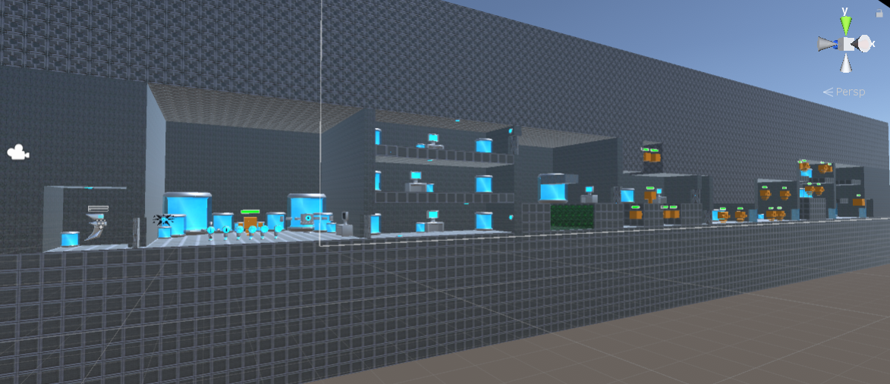

Decorated the entire map with props.

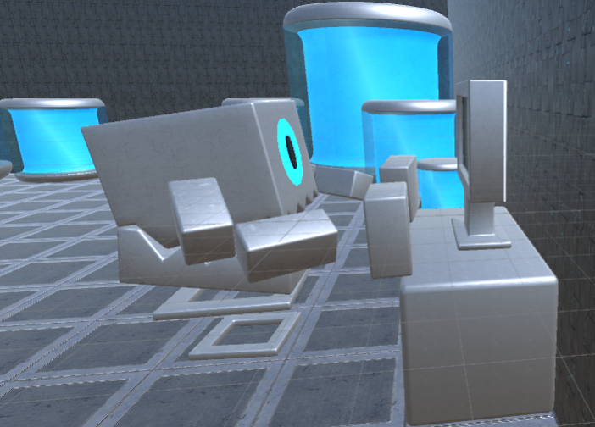

Implemented the Trainer Bot rig.

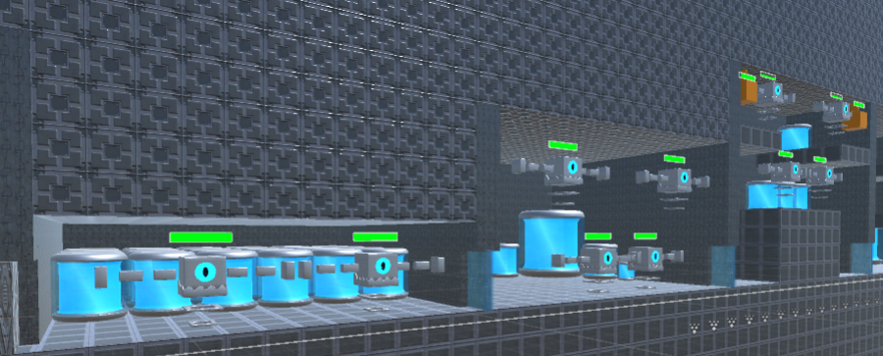

Refined the Hoverer enemies into Trainer Bot enemies.

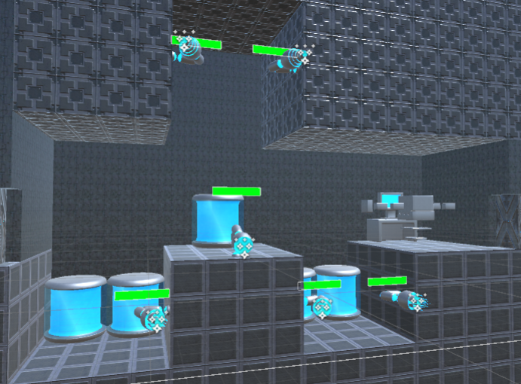

Refined the sentry enemies into turret enemies using inverse kinematics, as well as variants of particles and change in hitbox to ensure it doesn’t aim through walls.

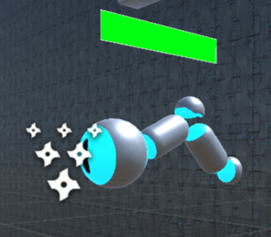

Implemented and refined the Door Keeper elite enemy to increase the difficulty in one of the rooms.

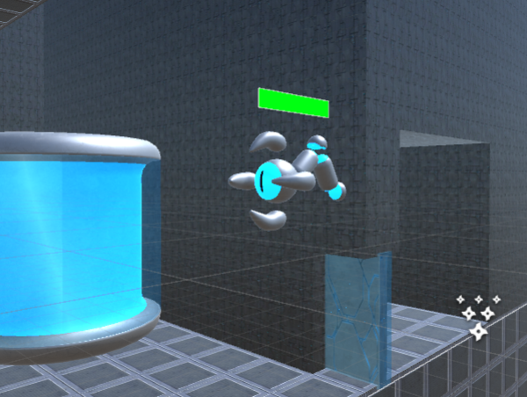

Refined the miniboss sentry enemy into the Door Guardian miniboss enemy.

9/07/2019

Successfully implemented sound and finished the UI.

Created the main menu and credits.

Finished the secret.

Game now has a win condition.

Paul Daniel Mihai